Technical Specifications

RET Control Cable din 8pin M/F

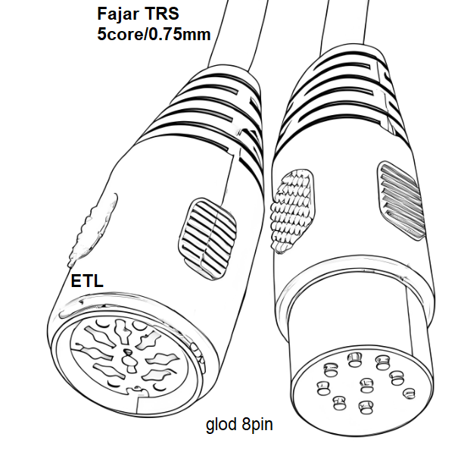
ETL-AISG-Din Male to Female

Main Features
AISG 3.0 Compliant RET Control Cable Feeds Data & DC Power to RET Components

Electrical Data

Protocol | 3GPP/AISG 3.0/AISG 2.0/AISG 1.1
Voltage, Rated | 300 V

Environmental Data
Operating Temperature Range -40°C to +70°C | -40°F to +158°F Relative Humidity 5% - 95%
Weather Protection IP67

Mechanical Data
AISG Connector A 8-Pin DIN Female, gold plated
AISG Connector B 8-Pin DIN Male, gold plated
Braid Coverage Coverage Rate ≥85 %
Data Conductor Type 0.32 mm² (22 AWG) twisted pair
Data Conductors, Quantity 2
Power Conductor Type 0.75 mm² (19 AWG) stranded
Power Conductors, Quantity 4
Total Conductors, Quantity 6
Shield Material Aluminum
Jacket Material UV protection ( Made in Malaysia)
Color Black
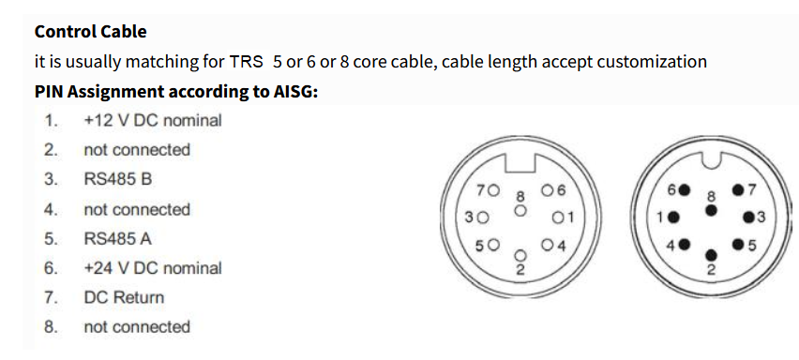
Diameter Over Jacket 8.00 mm

